Name _______________________________________

Date _______________________________________

Honors Biology

Protein, Enzyme, and “Spiraled” Material

Part 1 – Multiple Choice and Shot Answer Questions (Proteins and Enzymes) – Pease circle the letter of the most correct answers or place your answers in the spaces provided for each of the following.

1. Proteins contain which of the following elements (Note: Do not include any “R” group atoms in your decision)?

a. Carbon, Hydrogen, and Oxygen

b. Hydrogen and Nitrogen

c. Carbon, Hydrogen, Oxygen, and Nitrogen

d. Hydrogen, Oxygen, Nitrogen

2.Amino acids differ from one another by…

a. The chemical properties of their R groups

b. The chemical properties of their amino and carboxylic groups

c. The number of amino groups on a single amino acid

d. The number of carbon atoms that they contain

3.Glucose molecules are to starch as _______ are to proteins.

a. Oils

b. Monosaccharides

c. Amino acids

d. Fatty acids

Use the image of the molecule below in order to answer the questions that follow (4-8):

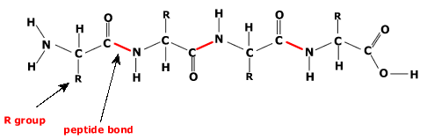

4. How many total amino acids can be identified in the molecule above?

a. 1

b. 2

c. 3

d. 4

5. The end of this molecule that is labeled with a “T” is known as the:

a. Alpha Terminus

b. N-Terminus

c. C – Terminus

d. Beta Terminus

6. How many peptide bonds can be identified in the molecule above?

a.1

b.2

c.3

d.4

7. How many total molecules of water needed to be removed from in-between the amino acids in the molecule above in order to link them all together AND which reaction needed to be employed in order for these amino acids be linked together?

a. 4, condensation (dehydration) synthesis

b. 3, hydrolysis

c. 4, hydrolysis

d. 3, condensation (dehydration) synthesis

8. Which specific level of protein structure is being identified in the diagram above?

a. Primary

b. Secondary

c. Tertiary

d. Quaternary

Use the diagram below in order to answer the two questions that follow (9-10). The diagram below is of a protein that consists of four, separate polypeptide chains that has been folded into one, complex 3-dimensional structure.

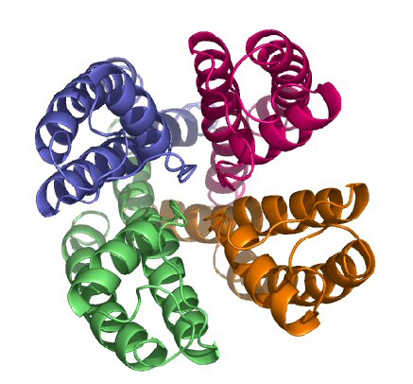

9. Based on the above information, which specific level of protein structure is the protein molecule above?

a. Primary

b. Secondary

c. Tertiary

d. Quaternary

10. Does the protein shown above contain any evidence of having secondary structure?

a. Yes

b. No

11. Enzyme names usually end in what suffix?

a. –ose

b. –ase

c. –gar

d. -eet

12. A monosaccharide is to glycogen as a(an)_______________________ is to an enzyme

a. Amino acid

b. Fatty acid

c. Nucleotide

d. Glycerol

13. In the equation 2H2 + O2 → 2H2O, the H2 molecules are the ________ and the H2O molecules are the ________.

a. Reactants . . . products

b. Products . . . reactants

14. What is the general function of enzymes within a cell?

a. To increase the activation energy of reactions that occur within a cell

b. To prevent any chemical reactions from occurring in a cell

c. To slow down the rate that reactions occur within a cell

d. To speed up chemical reactions that occur within a cell

15. In this image, which number represents the substrate?

a. 1

b. 2

c. 3

d. 5

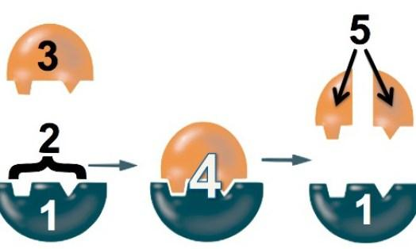

16. Some people cannot digest milk products because they lack a specific enzyme. Which enzyme would be used to break down the lactose in milk?

a. Maltase

b. Lactase

c. Active site

d. Protease

17. A certain enzyme will hydrolyze (break apart) egg whites but the enzyme will not break apart starch. Which statement best explains this observation?

a. Starch molecules are too large to be hydrolyzed (that is, broken down using hydrolysis).

b. Enzyme molecules are specific in their actions.

c. Starch is composed of amino acids.

18. Enzymes are molecules that are a part of which organic macromolecule “family”?

a. Carbohydrates

b. Proteins

c. Lipids

d. Nucleic Acids

19. A child is brought to the hospital with a fever of 107°F. Doctors immediately order an ice bath to lower the child's temperature. Which of the following statements offers the most logical explanation for this action?

a. Elevated body temperature will IMMEDIATELY prevent any reactions from occurring inside the body of the child

b. Elevated body temperatures may denature enzymes. This would interfere with the cell's abilities to catalyze various reactions.

c. Elevated body temperatures will increase the energy of activation needed to start various chemical reactions in the body. This will interfere with the ability of enzymes to catalyze vital chemical reactions.

d. Elevated body temperatures cause molecules to vibrate more quickly and prevent enzymes from easily attaching to reactants. This would slow vital body reactions.

Use the following paragraph (and graph) in order to answer the questions that follow (20-22):

The enzyme catalase speeds up the chemical reaction that breaks apart hydrogen peroxide (H2O2) producing oxygen (O2) and water (H2O). The graph below shows the effect of increasing the concentration of the enzyme catalase on the rate of oxygen produced. Use this information to answer the following questions.

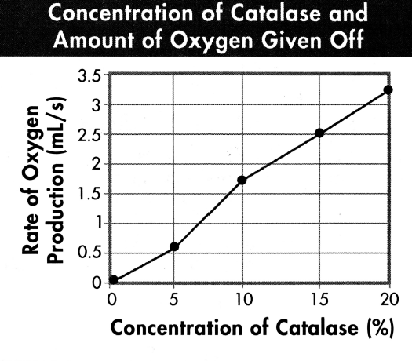

20.Based on the graph below, what can you conclude about the relationship between enzyme concentration and the rate of oxygen production?

a. Oxygen production decreases with increasing enzyme concentrations

b. Oxygen production increases with decreasing enzyme concentrations

c. Oxygen production increases with increasing enzyme concentrations

d. Oxygen production is not altered in any way with increasing enzyme concentrations

21. Based on your knowledge of enzymes and the information above, into which group of macromolecules would you categorize catalase.

a. Carbohydrates

b. Lipids

c. Proteins

d. Nucleic acids

22. Based on the information above, identify the independent variable and dependent variable in this experiment.

a. Independent variable: oxygen production (mL/s); dependent variable: concentration of catalase (%)

b. Independent variable: temperature (ºC); dependent variable: concentration of catalase (%)

c. Independent variable: concentration of catalase (%); dependent variable: oxygen production (mL/s);

d. There is not enough information to determine the independent and dependent variables.

Use the diagram below in order to answer the questions that follow (23-27). Please note that this diagram represents a single polypeptide chain that has been folded into a more complex, 3-dimensional shape.

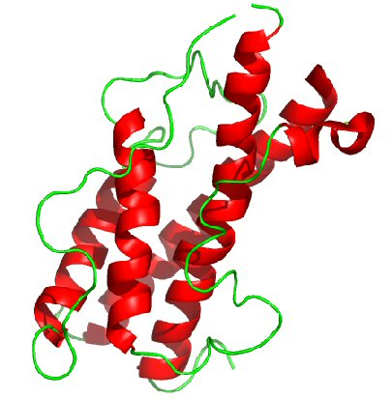

23. At which specific level of protein structure is the molecule pictured above? ____________________________________________

24. What is the specific name of the structure (shape) identified as “A” on the diagram above? ________________________

25. What specific type of bonds are used to hold structure (shape) “A” together? __________________________________

26. The molecule pictured above is composed of a total of 2,411 monomers. This being the case, how many total R-groups does this molecule contain? _____________________

27. Which terminus (end) is being identified by the letter “B” on the above molecule (the N or C terminus)? ________________________

28. Provide two functions for proteins in the cell (or in an organism).

1. _________________________________________________________________________________________________________

b. _______________________________________________________________________________

Use the information below in order to answer the following (29-31)

The graphs below represent data collected from an experiment in which the activity levels (measured as “Rate of Reaction”) of two different enzymes (“A” and “B”) under different environmental conditions (temperature and pH) were assessed. The **top** graph compares temperature and enzyme activity while the **bottom** graph compares pH and enzyme activity.

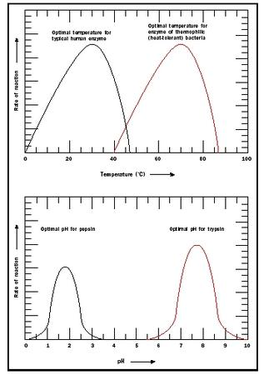

Based upon only this information:

29. (True or False) The optimal (optimum) temperature for both enzyme “A” and “B” is 450C

30. Which enzyme (“A” or “B”) would NOT be able to function (that is, show at least some significant activity) in a solution in which the H+ concentration is low? _____

31. Which enzyme (“A” or “B”) would work the best in an acidic environment? _____

Use the information below in order to answer the questions that follow (32-35)

The diagram shown below represents the metabolic “pathway” that is used in order to convert threonine (an amino acid) into isolucine (another amino acid) in the cell.

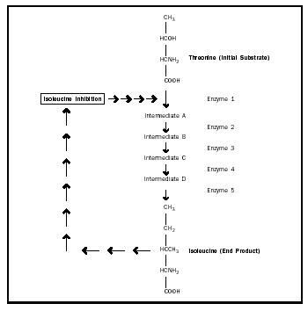

Based upon this information:

32. Since isoleucine is acting to inhibit the activity of the first enzyme shown above, it can be said that the entire pathway (that is, the conversion of threonine to isoleucine) is under a specific type of inhibiting “control”. What is the name of this type of inhibiting “control”? (NOTE: Your answer should NOT be a specific type of enzyme---such as allosteric, competitive, or non-competitive) ___________________________________________

33. If a chemical substance was added to the cell so that enzyme four was degraded (broken down), which of the intermediates listed above would immediately begin to build up in the cell? __________________________

34. A scientist extracts only enzyme (2) from the pathway above for further study. During her work, she finds that this enzyme loses its 3-dimensional shape (structure) and, therefore, its function at 250 0F. Based upon this information, what “specific” term can be used to describe what happened to this enzyme at 250 0F? _________________________________________________

35. The substrate for enzyme 3 is ____________________________________

36. In the space provided, please explain what type of inhibitor is being depicted in the diagram below and (using the image below as a reference) explain the reason for your answer.

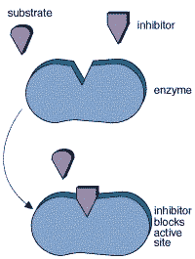

____________________________________________________________________________________________________________________________________________________________________________________________________________________________________________________________________________________________________________________________________________________________________________________________________________________________________________________________________________________________________________________________________

37. Which of the following graphs would best describe the effect of increasing substrate concentration on the rate of an enzyme catalyzed reaction (assume the amount of enzyme present during the reaction remains relatively constant—that is, it does not increase or decrease appreciably) (please circle the most correct graph)

A B.

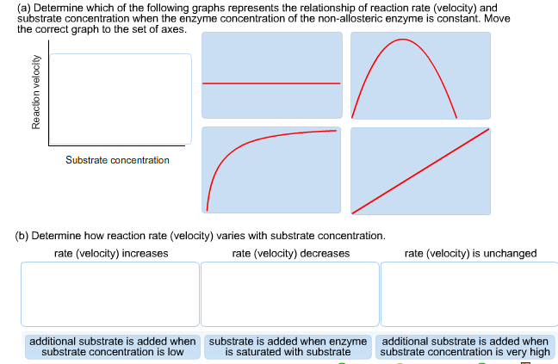

C. D.

Part 2: Spiraled Section – Please place the most correct answers in the spaces or on the lines provided.

38. In the space below, please draw the molecular structure of a single unsaturated fatty acid. This fatty acid MUST have all of the correct fatty acid components AND MUST ALSO INCLUDE THE FOLLOWING:

1. A carbon “tail” composed of a total of FIVE carbon atoms (this number of carbon atoms does NOT include the carbon atom that is a part of the carboxyl group)
2. One double bond between any two of the carbon atoms that you have just drawn in the carbon “tail” mentioned in “a”.
3. The correct number of hydrogen atoms bonded to the molecule.

Use the molecule that you have drawn in the space above in order to answer the questions that follow (39-42)

39. How many of the molecule that you drew above would be required to make 45 molecules of glycogen? _____

40. How many of the molecule that you drew above would be required to make 104 phospholipids? _____

41. How many of the molecule that you drew above would be required to make 92 triglyceride molecules? _____ How many total molecules of water would need to be removed in order to generate these 92 triglyceride molecules? _____

42. Is the molecule that you have drawn in the space above organic or inorganic?

______________________________

Read the paragraph(s) below in order to answer the questions that follow. Please circle the letter of the most correct answer for each. (43-54)

A student is taking a test in her cell biology course. One of the questions on the test asks her to identify an unknown type of cell. The image of this cell is shown below:

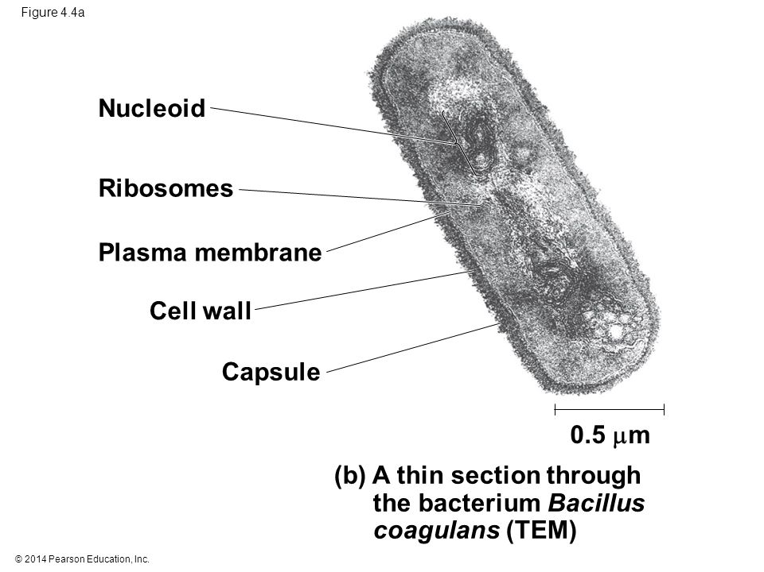

Under this image, a description of this cell followed:

“This cell is unique in that it has been found to survive in many different aquatic habitats throughout the world. Internally, it has been found to contain the same materials as any other cell of this type, however, the cell membrane is composed of 2 bilayers, each layer of which is composed of a total of 22,200 individual phospholipids. This cell membrane is also composed of two proteins (each of which is composed of a total of 64 amino acids that have been joined end-to-end into a chain), and a special carbohydrate that consists of 4,000 glucose units that have also been linked end-to-end into a chain. Additionally, it has also been found that this cell does not have a membrane surrounding its genetic material.”

43. Based on the above description, the student would best categorize this cell as being:

a. A prokaryotic cell

b. A eukaryotic cell

44. As a result of the student’s selection for question 43, which of the following descriptions / processes / structures would apply to this cell? (Please circle SIX of these choices)

a. The cell contains ribosomes

b. The cell can undergo reproduction

c. The cell contains DNA

d. The cell can undergo division

e. The cell contains many organelles

f. The cell contains a nucleus

g. The cell is not composed of atoms

h. The cell contains cytoplasm

i. The cell contains organic molecules

45. If a single “layer” of the cell membrane found surrounding this cell contains 22,200 individual phospholipids, the student can also assume that this “layer” of the cell membrane also consists of ______________ glycerol molecules and ____________ fatty acids.

a.22,200; 44,400

b.44,000; 22,200

c.22,200; 22,200

d. 44,400; 44,400

46. If each one of the proteins found in the membrane of this cell contains 64 amino acids, how many total peptide bonds do each of these proteins contain?

a.64 in each protein

b.128 in each protein

c.32 in each protein

d 63 in each protein

47. Which of the of the following would best describe the carbohydrate that can be found in the membrane of this cell?

a. It is a monomer and also a polysaccharide

b. It is a disaccharide and also a monomer

c. It is a polysaccharide and also a polymer

d. It is a monosaccharide and also a monomer

Following this part of the test, the student is asked several questions about a few of the molecules that have been identified within this cell----many of which can be found in the cells of humans. A picture of 5 of these molecules can be found below:

|  |  |
| --- | --- |
| A. | B. |
| C. | D. |
| E. |  |

Based on these images, the student is asked to answer the following questions (48-56). (**PLEASE NOTE: SOME OF THESE QUESTIONS MAY HAVE MORE THAN ONE ANSWER!! CIRCLE ALL THAT APPLY!!)**

48. Which molecule(s) (A, B, C, D, E, all, none) can be hydrolyzed from starch and used as a source of short-term energy in a plant cell?

49. Which molecule(s) (A, B, C, D, E, all, or none) is (are) examples of monosaccharides?

50. Which molecule(s) (A, E, neither, or both) contain(s) no glycerol?

51. Which molecule(s) (A, E, neither, or both) contain(s) saturated fatty acids?

52. Which molecule(s) (A, B, C, D, E, all, or none) is (are) considered to be organic?

53. Which molecule(s) (A, B, C, D, E, all, or none) is (are) considered to be lipids?

54. Does the molecule labeled “E” contain any glycogen within its structure? (Yes or No)

55. Is the molecule labeled “D” a monomer of a larger storage polysaccharide that can be found in human muscle and liver cells? (Yes or No)

56. Which molecule(s) (A, B, C, D, E, all, or none) is (are) triglycerides?

Part 3: Graphing Section – Please place the most correct answers in the spaces or on the lines provided.

Use the information below in order to answer the questions that follow (57-60)

The effect of temperature on the action of pepsin, a protein digesting enzyme (an enzyme that breaks down proteins) present in stomach fluid, was tested. In this investigation, 20 milliliters of stomach fluid and 10 grams of protein were placed into 5 test tubes. The tubes were then kept at different temperatures. After 24 hours, the contents of the tube were tested to determine the amount of protein that had been digested. The results are shown in the table below:

Based on this information:

57. What is the dependent variable in this investigation? ________________________________________

58. If a sixth test tube identical to the other tubes was kept at a temperature of 300C for 24 hours, the amount of protein digested would most likely be:

a. Less than 1.0 grams

b. Between 1.0 and 4.0 grams

c. Between 4.0 and 9.0 grams

d. More than 9.0 grams

59. This investigation was repeated using ten grams of starch instead of protein in each test tube. The contents of each tube were tested to determine the amount of starch that had been digested. The test result showed that no starch digestion occurred. On the lines provided, explain why no starch was digested.

__________________________________________________________________________________________________________________________________________________________________________________________________________________________________________________________________

60. What is the difference in the amount of protein being digested when one compares 10oC and 37oC? _________

Name _______________________________________

Date _______________________________________

Honors Biology

Protein, Enzyme, and “Spiraled” Material

Part 1 – Multiple Choice and Shot Answer Questions (Proteins and Enzymes) – Pease circle the letter of the most correct answers or place your answers in the spaces provided for each of the following.

1.Amino acids differ from one another by…

a. The chemical properties of their R groups

b. The chemical properties of their amino and carboxylic groups

c. The number of amino groups on a single amino acid

d. The number of carbon atoms that they contain

2. Proteins contain which of the following elements (Note: Do not include any “R” group atoms in your decision)?

a. Carbon, Hydrogen, and Oxygen

b. Hydrogen and Nitrogen

c. Carbon, Hydrogen, Oxygen, and Nitrogen

d. Hydrogen, Oxygen, Nitrogen

3.Glucose molecules are to starch as _______ are to proteins.

a. Oils

b. Monosaccharides

c. Amino acids

d. Fatty acids

Use the image of the molecule below in order to answer the questions that follow (4-8):



4. The end of this molecule that is labeled with a “T” is known as the:

a. Alpha Terminus

b. N-Terminus

c. C – Terminus

d. Beta Terminus

5. How many total amino acids can be identified in the molecule above?

a. 1

b. 2

c. 3

d. 4

6. Which specific level of protein structure is being identified in the diagram above?

a. Primary

b. Secondary

c. Tertiary

d. Quaternary

7. How many peptide bonds can be identified in the molecule above?

a.1

b.2

c.3

d.4

8. How many total molecules of water needed to be removed from in-between the amino acids in the molecule above in order to link them all together AND which reaction needed to be employed in order for these amino acids be linked together?

a. 4, condensation (dehydration) synthesis

b. 3, hydrolysis

c. 4, hydrolysis

d. 3, condensation (dehydration) synthesis

Use the diagram below in order to answer the two questions that follow (9-10). The diagram below is of a protein that consists of four, separate polypeptide chains that has been folded into one, complex 3-dimensional structure.



9. Based on the above information, which specific level of protein structure is the protein molecule above?

a. Primary

b. Secondary

c. Tertiary

d. Quaternary

10. Does the protein shown above contain any evidence of having secondary structure?

a. Yes

b. No

11. What is the general function of enzymes within a cell?

a. To increase the activation energy of reactions that occur within a cell

b. To prevent any chemical reactions from occurring in a cell

c. To slow down the rate that reactions occur within a cell

d. To speed up chemical reactions that occur within a cell

12. Enzyme names usually end in what suffix?

a. –ose

b. –ase

c. –gar

d. -eet

13. A monosaccharide is to glycogen as a(an)_______________________ is to an enzyme

a. Amino acid

b. Fatty acid

c. Nucleotide

d. Glycerol

14. In the equation 2H2 + O2 → 2H2O, the H2 molecules are the ________ and the H2O molecules are the ________.

a. Reactants . . . products

b. Products . . . reactants

15. In this image, which number represents the substrate?

a. 1

b. 2

c. 3

d. 5



16. A child is brought to the hospital with a fever of 107°F. Doctors immediately order an ice bath to lower the child's temperature. Which of the following statements offers the most logical explanation for this action?

a. Elevated body temperature will IMMEDIATELY prevent any reactions from occurring inside the body of the child

b. Elevated body temperatures may denature enzymes. This would interfere with the cell's abilities to catalyze various reactions.

c. Elevated body temperatures will increase the energy of activation needed to start various chemical reactions in the body. This will interfere with the ability of enzymes to catalyze vital chemical reactions.

d. Elevated body temperatures cause molecules to vibrate more quickly and prevent enzymes from easily attaching to reactants. This would slow vital body reactions.

17. Some people cannot digest milk products because they lack a specific enzyme. Which enzyme would be used to break down the lactose in milk?

a. Maltase

b. Lactase

c. Active site

d. Protease

18. A certain enzyme will hydrolyze (break apart) egg whites but the enzyme will not break apart starch. Which statement best explains this observation?

a. Starch molecules are too large to be hydrolyzed (that is, broken down using hydrolysis).

b. Enzyme molecules are specific in their actions.

c. Starch is composed of amino acids.

19. Enzymes are molecules that are a part of which organic macromolecule “family”?

a. Carbohydrates

b. Proteins

c. Lipids

d. Nucleic Acids

Use the following paragraph (and graph) in order to answer the questions that follow (20-22):

The enzyme catalase speeds up the chemical reaction that breaks apart hydrogen peroxide (H2O2) producing oxygen (O2) and water (H2O). The graph below shows the effect of increasing the concentration of the enzyme catalase on the rate of oxygen produced. Use this information to answer the following questions.



20. Based on the information above, identify the independent variable and dependent variable in this experiment.

a. Independent variable: oxygen production (mL/s); dependent variable: concentration of catalase (%)

b. Independent variable: temperature (ºC); dependent variable: concentration of catalase (%)

c. Independent variable: concentration of catalase (%); dependent variable: oxygen production (mL/s);

d. There is not enough information to determine the independent and dependent variables.

21.Based on the graph below, what can you conclude about the relationship between enzyme concentration and the rate of oxygen production?

a. Oxygen production decreases with increasing enzyme concentrations

b. Oxygen production increases with decreasing enzyme concentrations

c. Oxygen production increases with increasing enzyme concentrations

d. Oxygen production is not altered in any way with increasing enzyme concentrations

22. Based on your knowledge of enzymes and the information above, into which group of macromolecules would you categorize catalase.

a. Carbohydrates

b. Lipids

c. Proteins

d. Nucleic acids

Use the diagram below in order to answer the questions that follow (23-27). Please note that this diagram represents a single polypeptide chain that has been folded into a more complex, 3-dimensional shape.



23. At which specific level of protein structure is the molecule pictured above? ____________________________________________

24. What is the specific name of the structure (shape) identified as “A” on the diagram above? ________________________

25. What specific type of bonds are used to hold structure (shape) “A” together? __________________________________

26. Which terminus (end) is being identified by the letter “B” on the above molecule (the N or C terminus)? ________________________

27. The molecule pictured above is composed of a total of 2,411 monomers. This being the case, how many total R-groups does this molecule contain? _____________________

28. Provide two functions for proteins in the cell (or in an organism).

1. _________________________________________________________________________________________________________

b. _______________________________________________________________________________

Use the information below in order to answer the following (29-31)

The graphs below represent data collected from an experiment in which the activity levels (measured as “Rate of Reaction”) of two different enzymes (“A” and “B”) under different environmental conditions (temperature and pH) were assessed. The **top** graph compares temperature and enzyme activity while the **bottom** graph compares pH and enzyme activity.



Based upon only this information:

29. Which enzyme (“A” or “B”) would work the best in an acidic environment? _____

30. (True or False) The optimal (optimum) temperature for both enzyme “A” and “B” is 450C

31. Which enzyme (“A” or “B”) would NOT be able to function (that is, show at least some significant activity) in a solution in which the H+ concentration is low? _____

Use the information below in order to answer the questions that follow (32-35)

The diagram shown below represents the metabolic “pathway” that is used in order to convert threonine (an amino acid) into isolucine (another amino acid) in the cell.



Based upon this information:

32. A scientist extracts only enzyme (2) from the pathway above for further study. During her work, she finds that this enzyme loses its 3-dimensional shape (structure) and, therefore, its function at 250 0F. Based upon this information, what “specific” term can be used to describe what happened to this enzyme at 250 0F? _________________________________________________

33. Since isoleucine is acting to inhibit the activity of the first enzyme shown above, it can be said that the entire pathway (that is, the conversion of threonine to isoleucine) is under a specific type of inhibiting “control”. What is the name of this type of inhibiting “control”? (NOTE: Your answer should NOT be a specific type of enzyme---such as allosteric, competitive, or non-competitive) ___________________________________________

34. If a chemical substance was added to the cell so that enzyme four was degraded (broken down), which of the intermediates listed above would immediately begin to build up in the cell? __________________________

35. The substrate for enzyme 3 is ____________________________________

36. In the space provided, please explain what type of inhibitor is being depicted in the diagram below and (using the image below as a reference) explain the reason for your answer.



____________________________________________________________________________________________________________________________________________________________________________________________________________________________________________________________________________________________________________________________________________________________________________________________________________________________________________________________________________________________________________________________________

37. Which of the following graphs would best describe the effect of increasing substrate concentration on the rate of an enzyme catalyzed reaction (assume the amount of enzyme present during the reaction remains relatively constant—that is, it does not increase or decrease appreciably) (please circle the most correct graph)

A B.



C. D.

Part 2: Spiraled Section – Please place the most correct answers in the spaces or on the lines provided.

38. In the space below, please draw the molecular structure of a single unsaturated fatty acid. This fatty acid MUST have all of the correct fatty acid components AND MUST ALSO INCLUDE THE FOLLOWING:

1. A carbon “tail” composed of a total of FIVE carbon atoms (this number of carbon atoms does NOT include the carbon atom that is a part of the carboxyl group)
2. One double bond between any two of the carbon atoms that you have just drawn in the carbon “tail” mentioned in “a”.
3. The correct number of hydrogen atoms bonded to the molecule.

Use the molecule that you have drawn in the space above in order to answer the questions that follow (39-42)

39. How many of the molecule that you drew above would be required to make 92 triglyceride molecules? _____ How many total molecules of water would need to be removed in order to generate these 92 triglyceride molecules? _____

40. How many of the molecule that you drew above would be required to make 45 molecules of glycogen? _____

41. How many of the molecule that you drew above would be required to make 104 phospholipids? _____

42. Is the molecule that you have drawn in the space above organic or inorganic?

______________________________

Read the paragraph(s) below in order to answer the questions that follow. Please circle the letter of the most correct answer for each. (43-54)

A student is taking a test in her cell biology course. One of the questions on the test asks her to identify an unknown type of cell. The image of this cell is shown below:



Under this image, a description of this cell followed:

“This cell is unique in that it has been found to survive in many different aquatic habitats throughout the world. Internally, it has been found to contain the same materials as any other cell of this type, however, the cell membrane is composed of 2 bilayers, each layer of which is composed of a total of 22,200 individual phospholipids. This cell membrane is also composed of two proteins (each of which is composed of a total of 64 amino acids that have been joined end-to-end into a chain), and a special carbohydrate that consists of 4,000 glucose units that have also been linked end-to-end into a chain. Additionally, it has also been found that this cell does not have a membrane surrounding its genetic material.”

43. Based on the above description, the student would best categorize this cell as being:

a. A prokaryotic cell

b. A eukaryotic cell

44. As a result of the student’s selection for question 43, which of the following descriptions / processes / structures would apply to this cell? (Please circle SIX of these choices)

a. The cell contains ribosomes

b. The cell can undergo reproduction

c. The cell contains DNA

d. The cell can undergo division

e. The cell contains many organelles

f. The cell contains a nucleus

g. The cell is not composed of atoms

h. The cell contains cytoplasm

i. The cell contains organic molecules

45. Which of the of the following would best describe the carbohydrate that can be found in the membrane of this cell?

a. It is a monomer and also a polysaccharide

b. It is a disaccharide and also a monomer

c. It is a polysaccharide and also a polymer

d. It is a monosaccharide and also a monomer

46. If a single “layer” of the cell membrane found surrounding this cell contains 22,200 individual phospholipids, the student can also assume that this “layer” of the cell membrane also consists of ______________ glycerol molecules and ____________ fatty acids.

a.22,200; 44,400

b.44,000; 22,200

c.22,200; 22,200

d. 44,400; 44,400

47. If each one of the proteins found in the membrane of this cell contains 64 amino acids, how many total peptide bonds do each of these proteins contain?

a.64 in each protein

b.128 in each protein

c.32 in each protein

d 63 in each protein

Following this part of the test, the student is asked several questions about a few of the molecules that have been identified within this cell----many of which can be found in the cells of humans. A picture of 5 of these molecules can be found below:

|  |  |
| --- | --- |
| A. | B. |
| C. | D. |
| E. |  |

Based on these images, the student is asked to answer the following questions (48-56). (**PLEASE NOTE: SOME OF THESE QUESTIONS MAY HAVE MORE THAN ONE ANSWER!! CIRCLE ALL THAT APPLY!!)**

48. Which molecule(s) (A, E, neither, or both) contain(s) saturated fatty acids?

49. Which molecule(s) (A, B, C, D, E, all, or none) is (are) considered to be organic?

50. Which molecule(s) (A, B, C, D, E, all, or none) is (are) considered to be lipids?

51. Does the molecule labeled “E” contain any glycogen within its structure? (Yes or No)

42. Which molecule(s) (A, B, C, D, E, all, none) can be hydrolyzed from starch and used as a source of short-term energy in a plant cell?

43. Which molecule(s) (A, B, C, D, E, all, or none) is (are) examples of monosaccharides?

54. Which molecule(s) (A, E, neither, or both) contain(s) no glycerol?

55. Is the molecule labeled “D” a monomer of a larger storage polysaccharide that can be found in human muscle and liver cells? (Yes or No)

56. Which molecule(s) (A, B, C, D, E, all, or none) is (are) triglycerides?

Part 3: Graphing Section – Please place the most correct answers in the spaces or on the lines provided.

Use the information below in order to answer the questions that follow (57-60)

The effect of temperature on the action of pepsin, a protein digesting enzyme (an enzyme that breaks down proteins) present in stomach fluid, was tested. In this investigation, 20 milliliters of stomach fluid and 10 grams of protein were placed into 5 test tubes. The tubes were then kept at different temperatures. After 24 hours, the contents of the tube were tested to determine the amount of protein that had been digested. The results are shown in the table below:

Based on this information:

57. What is the dependent variable in this investigation? ________________________________________

58. If a sixth test tube identical to the other tubes was kept at a temperature of 300C for 24 hours, the amount of protein digested would most likely be:

a. Less than 1.0 grams

b. Between 1.0 and 4.0 grams

c. Between 4.0 and 9.0 grams

d. More than 9.0 grams

59. This investigation was repeated using ten grams of starch instead of protein in each test tube. The contents of each tube were tested to determine the amount of starch that had been digested. The test result showed that no starch digestion occurred. On the lines provided, explain why no starch was digested.

__________________________________________________________________________________________________________________________________________________________________________________________________________________________________________________________________

60. What is the difference in the amount of protein being digested when one compares 10oC and 37oC? _________